Ansible Setup 2

7. Need to generate key from the common user login to communicate with the other nodes.

Master: Generate the key using common user and copy the key to remaining nodes.

sudo su - common_user

ssh-keygen

ssh-copy-id node_private_key

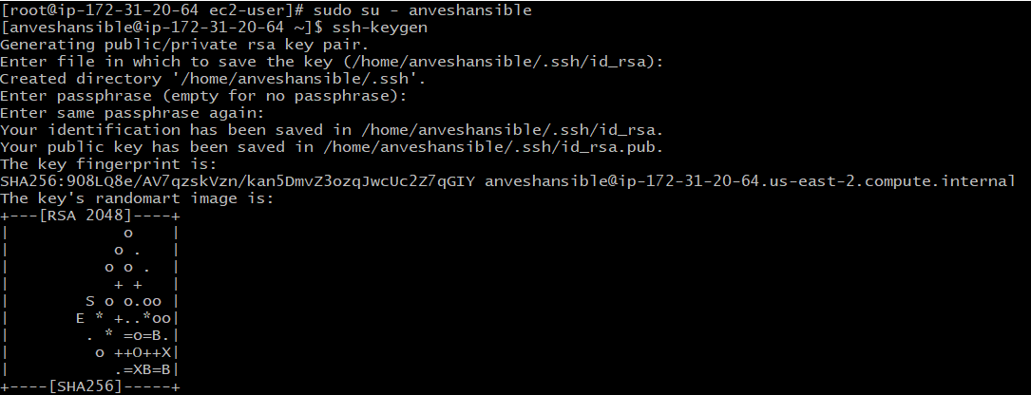

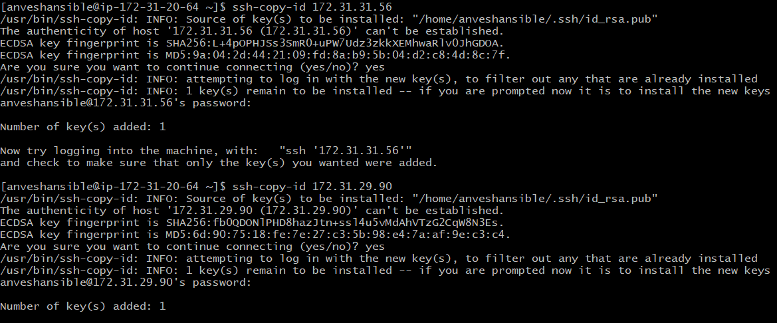

8. Add all the nodes' ip to the inventory of the master.

vim /etc/ansible/hosts

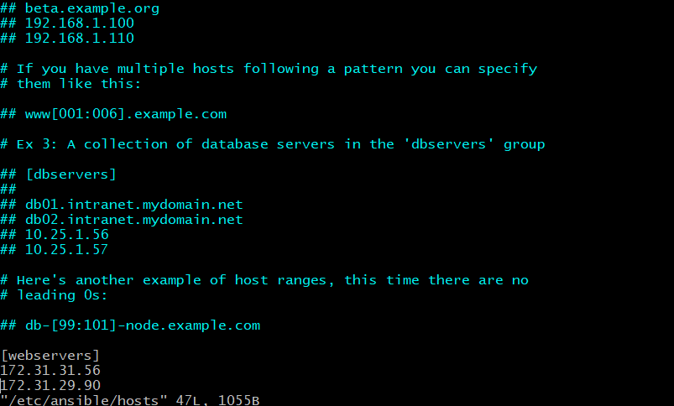

And check the connection of all the nodes in the master.

ansible -m ping webservers

(or) ansible -m ping all

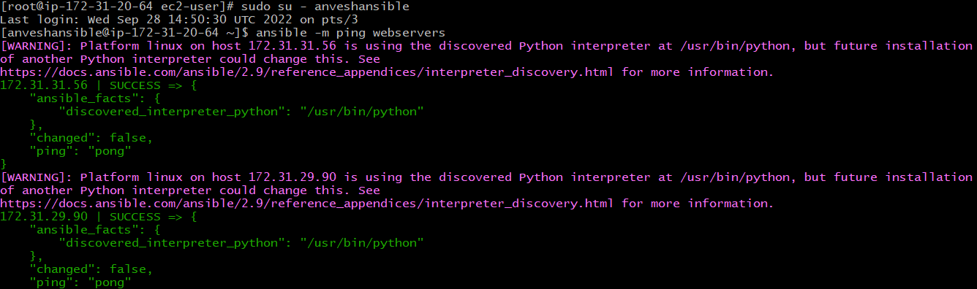

Modules: Predefined set of programs which are responsible to perform any task and are written in python. Need to pass arguments/attributes for any module.

Syntax: ansible [-i inventory_name] {group_name or server_name or both} -m [module] -a "arguments"

Here, inventory_name is optional.

Some of the commonly used modules:

get_url

copy

file

user

ping

yum

shell

service

unarchieve

Total no.of modules in ansible: ansible-doc -l | wc -l



Some common usages, Ex: ansible-doc -l | grep shell

ansible-doc shell

ansible all -m shell -a 'top'

ansible all -m shell -a 'df -h'

ansible all -m shell -a 'date'

ansible all -m shell -a 'uptime'

ansible all -m shell -a 'free -m'

ansible all -m ping

